Experiment No.8

Title: Execution of ETL process and OLAP operations

Batch: B3 Roll No.: 16010422230 Experiment No.:8

Aim: Execution of ETL process and OLAP operations

___________________________________________________________________________

Resources needed: Different RDBMS such as MySQL, Postgres and Excel, CSV,
RapidMiner 5.3/ Latest vision
___________________________________________________________________________

Theory

Data Warehouse:
An analytics-focused type of data management system called a data warehouse is intended to assist and allow business intelligence (BI) activities. Large amounts of historical data are frequently included in data warehouses, which are only designed to be used for queries and analysis. Application log files and transaction apps are only two examples of the many different sources from which the data in a data warehouse often comes.
Big data from various sources is centralised and combined in a data warehouse. Because of its analytical skills, businesses can get more out of their data and make better decisions. It gradually compiles a historical record that data scientists and business analysts can find quite useful. Because to these features, a data warehouse can be regarded as an organization's "single source of truth."

ETL:
Extract, Transform, Load (ETL) refers to a process in database usage and especially in data warehousing. Data extraction is where data is extracted from homogeneous or heterogeneous data sources; data transformation where the data is transformed for storing in the proper format or structure for the purposes of querying and analysis; data loading where the data is loaded into the final target database, more specifically, an operational data store, data mart, or data warehouse.
One may improve their chances of achieving better connection and scalability by employing a well-established ETL framework. A decent ETL tool must be able to interface with the several different relational databases and read the various file formats employed by a business. ETL solutions have started to move into Enterprise Application Integration, or even Enterprise Service Bus, systems that now encompass a lot more than simply the extraction, transformation, and loading of data. Converting CSV files into formats usable by relational databases is one frequent use case for ETL technologies. ETL solutions make it feasible for users to input csv-like data feeds/files and import it into a database with as little code as possible, facilitating a typical translation of millions of records. ESTL instruments

RapidMiner:
RapidMiner provides data mining and machine learning procedures including: data loading and transformation (Extract, transform, load (ETL)), data preprocessing and visualization, predictive analytics and statistical modelling, evaluation, and deployment. RapidMiner is written in the Java programming language. RapidMiner provides a GUI to design and execute analytical workflows. Those workflows are called “Processes” in RapidMiner and they consist of multiple “Operators”. Each operator performs a single task within the process, and the output of each operator forms the input of the next one. Alternatively, the engine can be called from other programs or used as an API. Individual functions can be called from the command line. RapidMiner provides learning schemes, models and algorithms and can be extended using R and Python scripts.

OLAP:
In computing, online analytical processing, or OLAP is an approach to answering multi-dimensional analytical (MDA) queries. OLAP is part of the broader category of business intelligence, which also encompasses relational database report writing and data mining. Typical applications of OLAP include business reporting for sales, marketing, management reporting, business process management (BPM), budgeting and forecasting, financial reporting and similar areas, with new applications coming up, such as agriculture. The term OLAP was created as a slight modification of the traditional database term OLTP (Online Transaction Processing).

OLAP tools enable users to analyse multidimensional data interactively from multiple perspectives. OLAP consists of three basic analytical operations: consolidation (roll-up), drill-down, and slicing and dicing. Consolidation involves the aggregation of data that can be accumulated and computed in one or more dimensions. For example, all sales offices are rolled up to the sales department or sales division to anticipate sales trends. By contrast, the drill-down is a technique that allows users to navigate through the details. For instance, users can view the sales by individual products that make up a region’s sales. Slicing and dicing is a feature whereby users can take out (slicing) a specific set of data of the OLAP cube and view (dicing) the slices from different viewpoints.

OLAP queries can be implemented by using analytical SQL functions

Oracle has extensions to ANSI SQL to allow to quickly computing aggregations and rollups.

These new statements include:

- rollup

- cube

- grouping

These simple SQL operators allow creating easy aggregations directly inside the SQL.

Creating tabular aggregates with ROLLUP:

ROLLUP enables an SQL statement to calculate multiple levels of subtotals across a specified group of dimensions. It also calculates a grand total. ROLLUP is a simple extension to the GROUP BY clause, so its syntax is extremely easy to use. Create cross-tabular reports with CUBE:

In multidimensional jargon, a “cube” is a cross-tabulated summary of detail rows. CUBE enables a SELECT statement to calculate subtotals for all possible combinations of a group of dimensions. It also calculates a grand total.

This is the set of information typically needed for all cross-tabular reports, so CUBE can calculate a cross-tabular report with a single select statement

__________________________________________________________________________

Activities:

For ETL:

- Install https://rapidminer.software.informer.com/download/#downloading
- Go through the tutorial provided by RapidMiner
- Extract data from 2 to 3 heterogeneous sources such as excel, MYSQL, Postgres etc.
- Download any data set from https://www.kaggle.com/datasets or similar website
- Apply five different transformations and filters to the data with specific requirement
- Prepare a report for the activities 2 and 4 (ETL part) with steps and visualisations applied.
- Create and save clean dataset in csv file.
- Import the csv file from step7 in PostgreSQL database.
- Apply rollup and cube operations to the same

Accessing Data

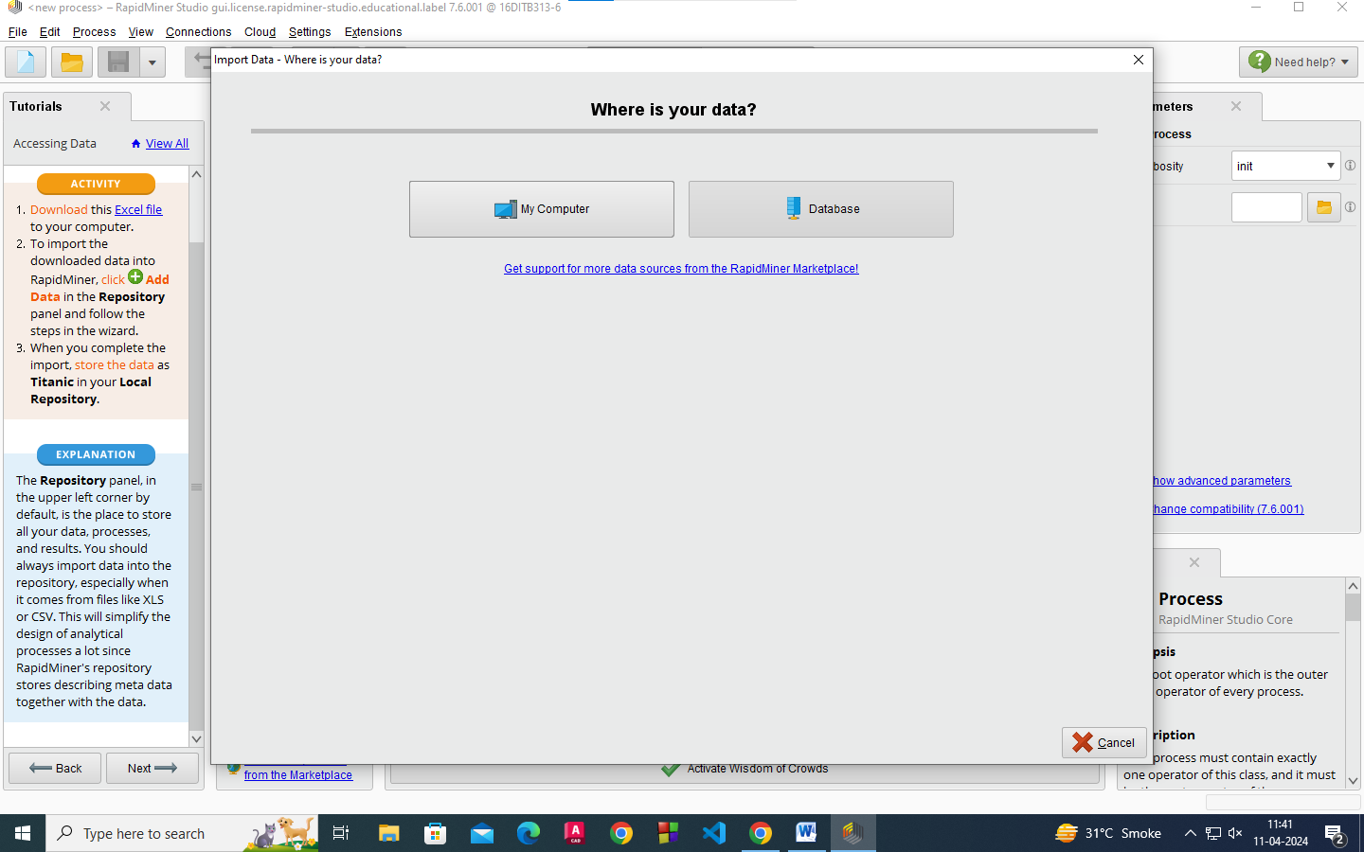

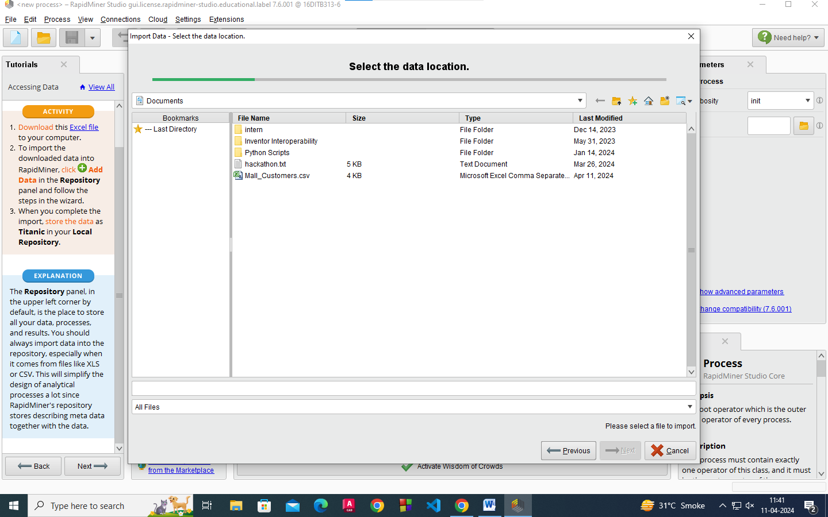
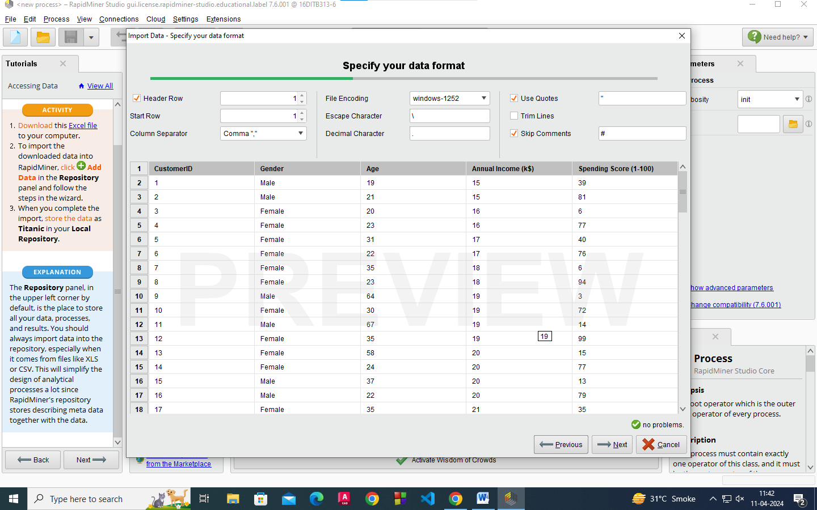

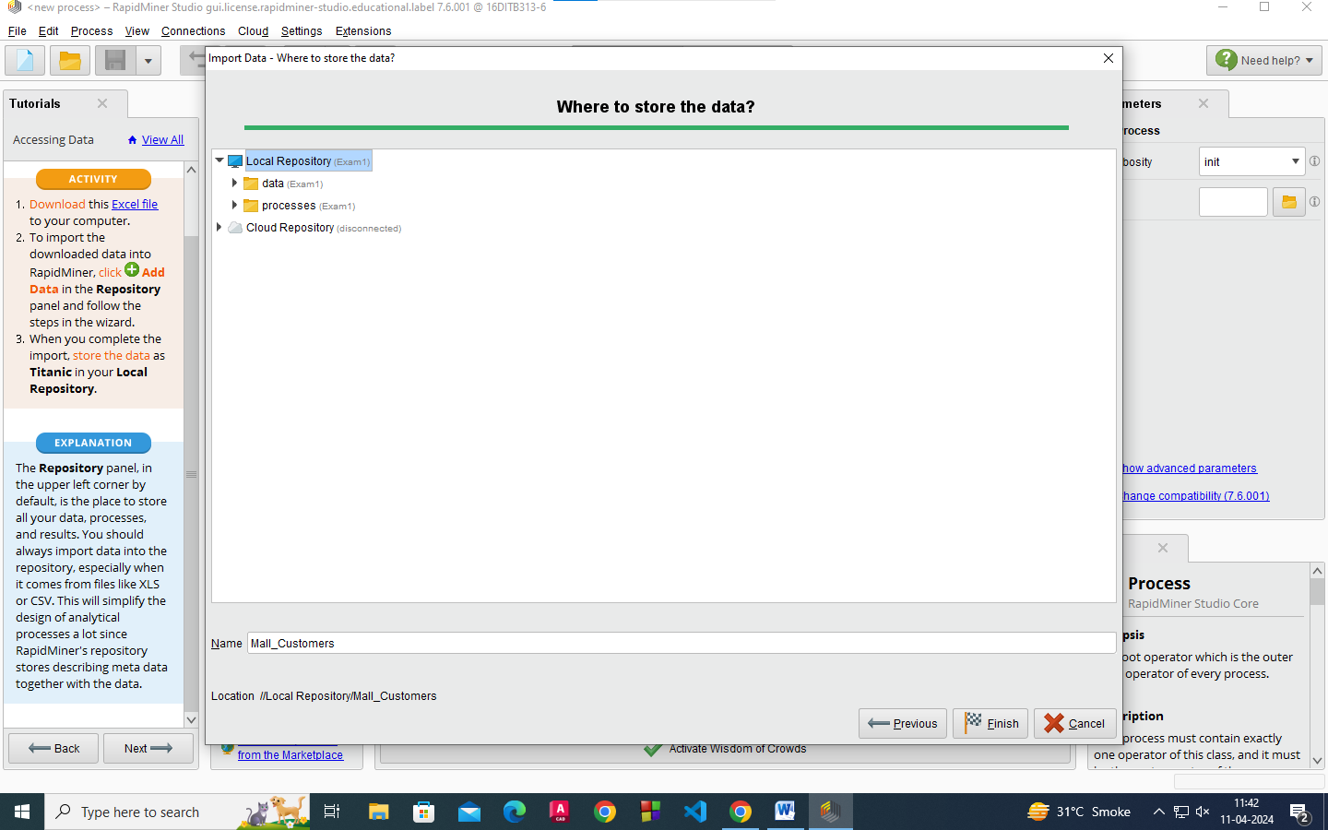
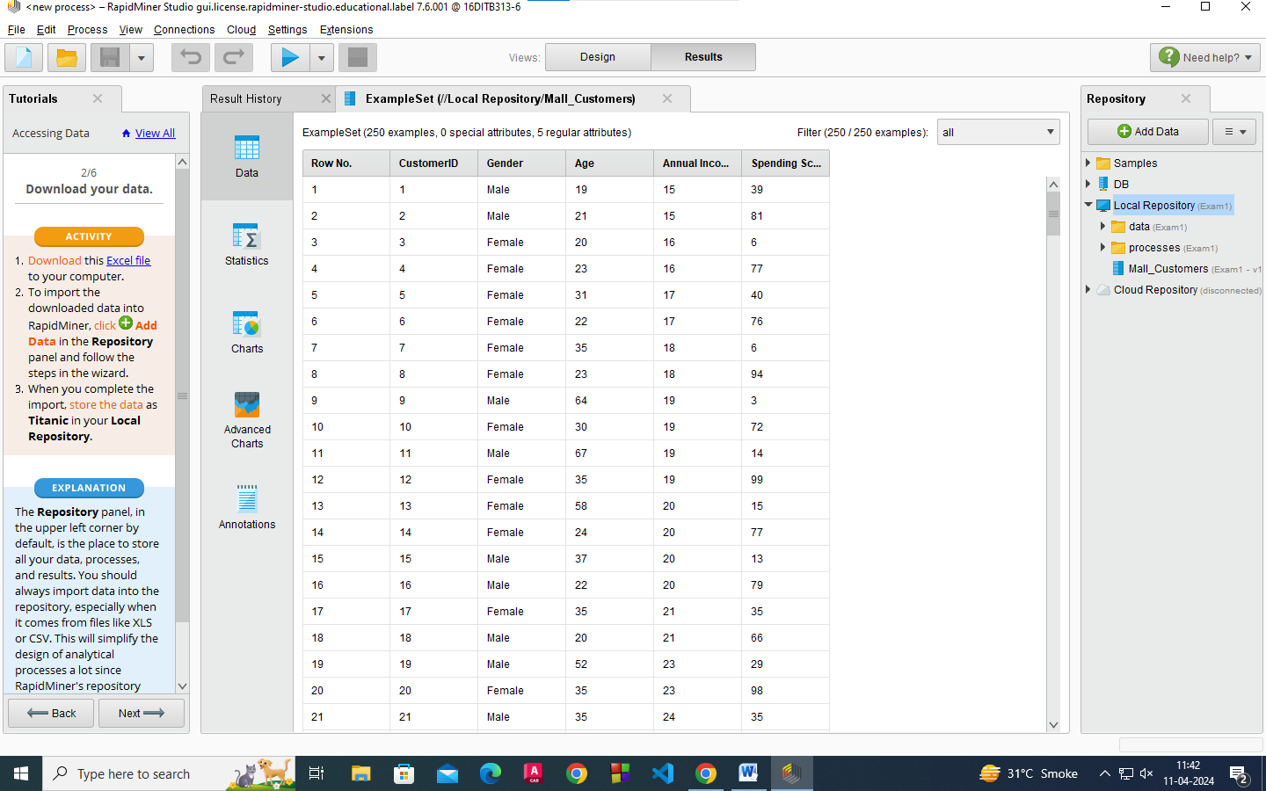

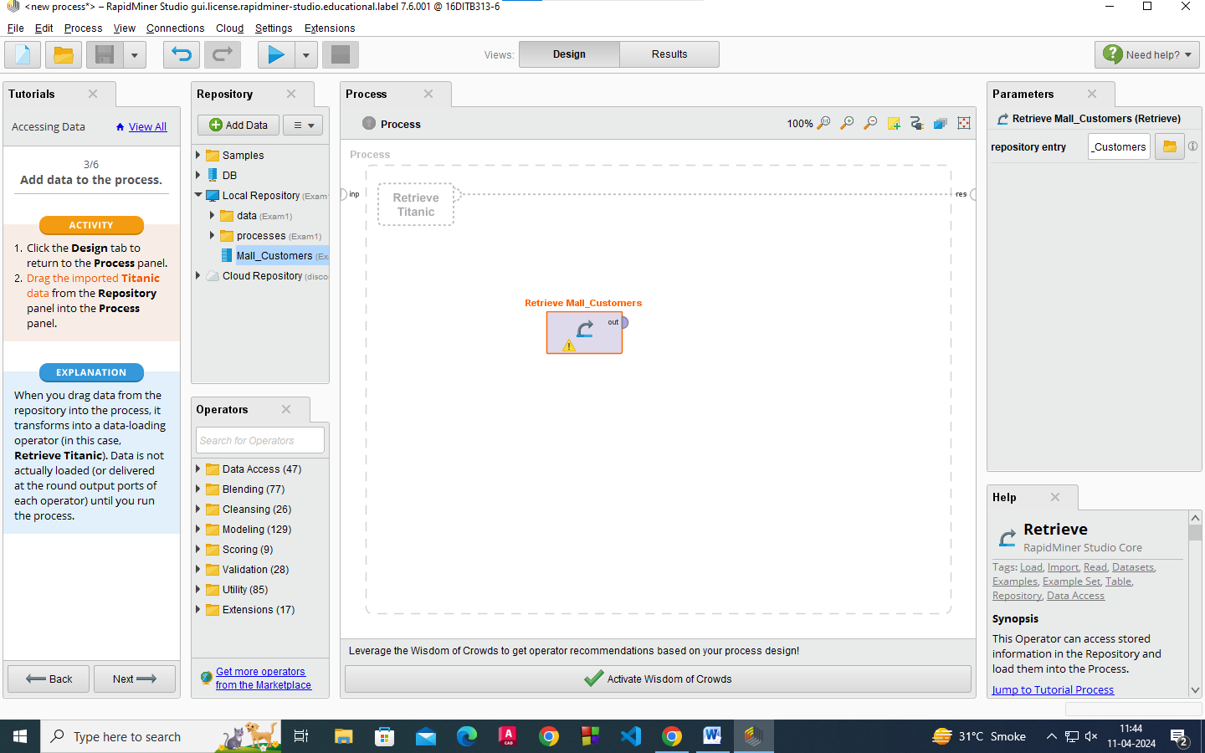
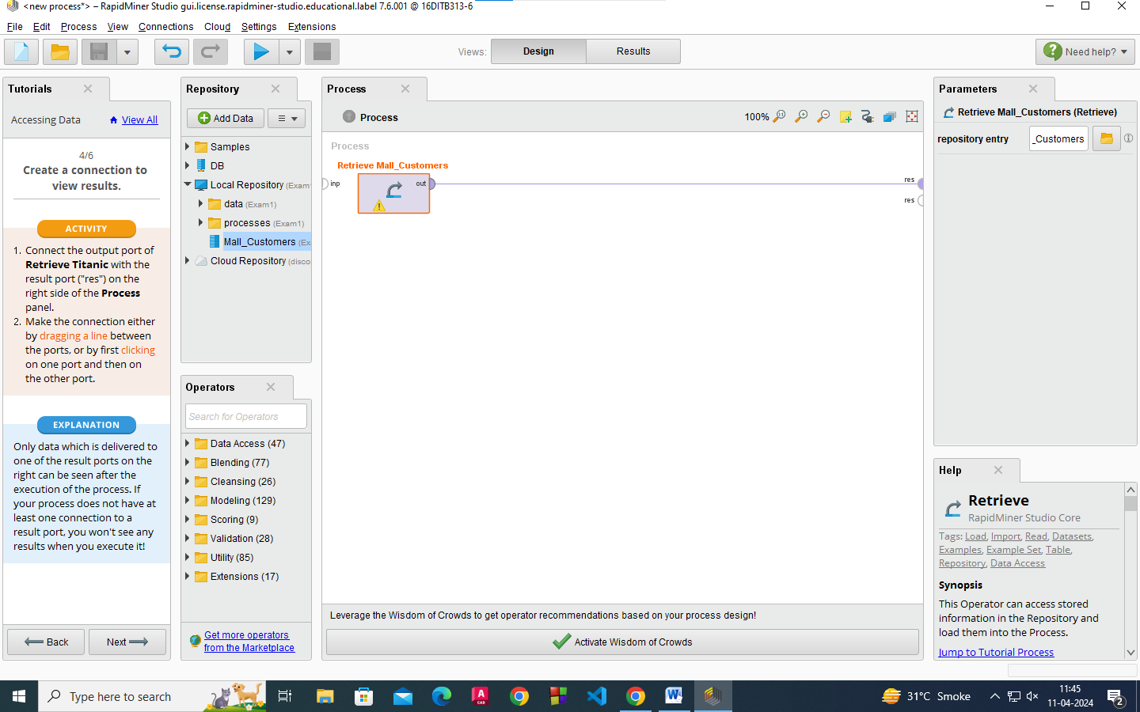

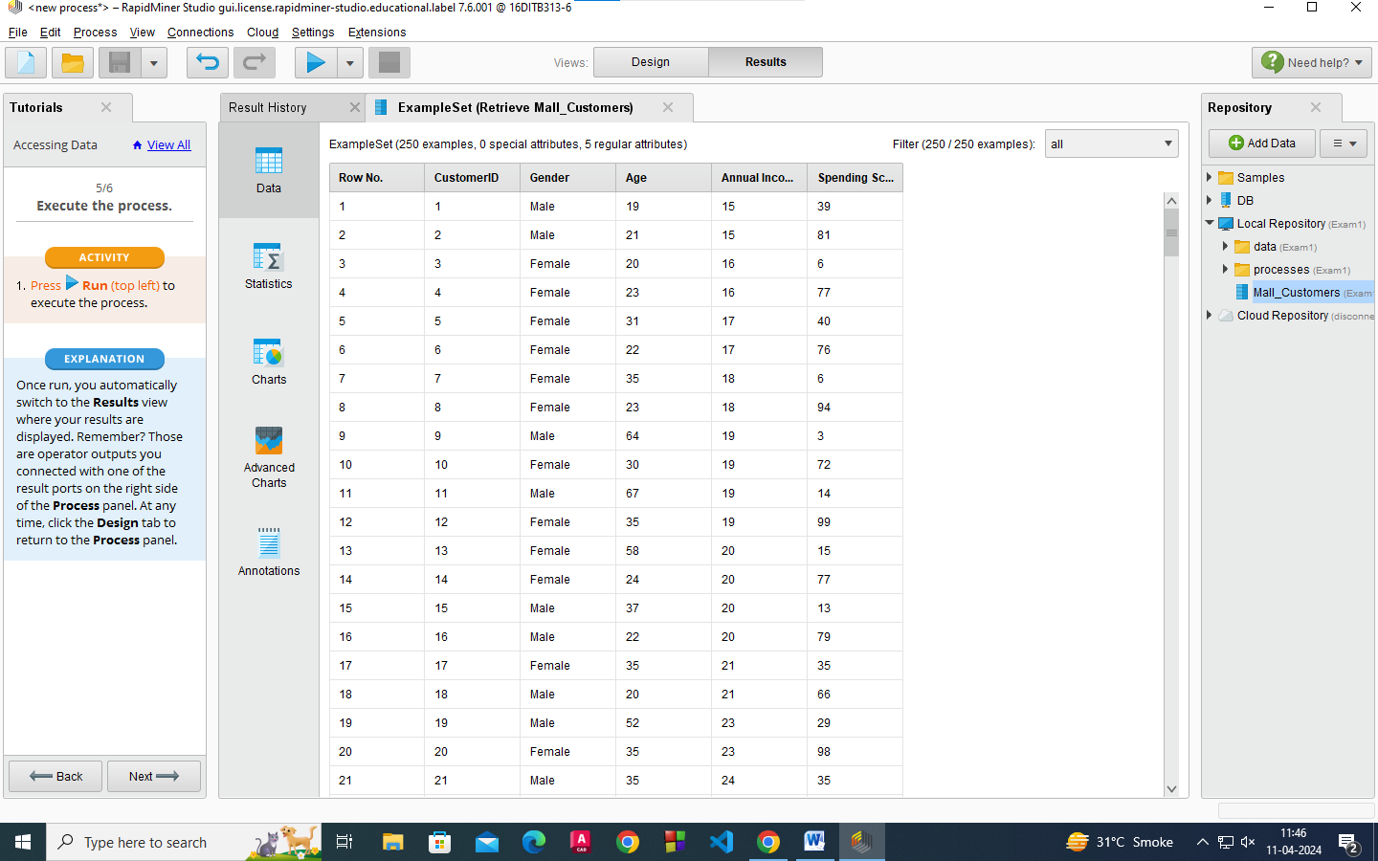
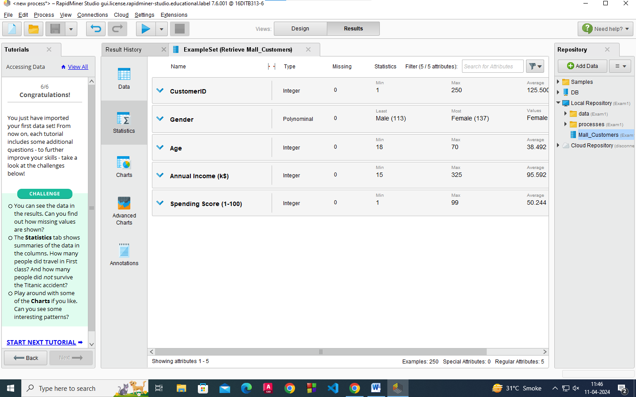

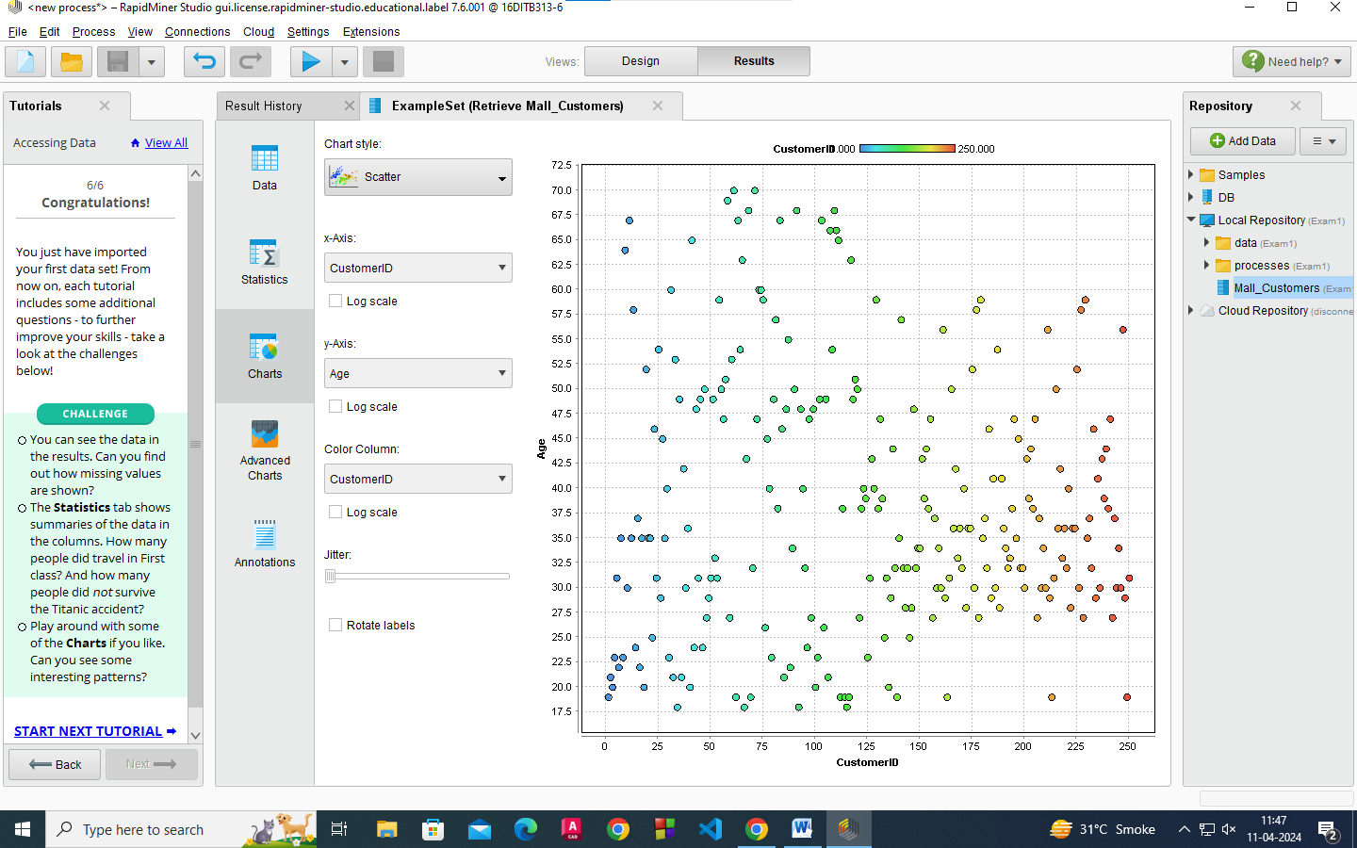

Filtering and Sorting

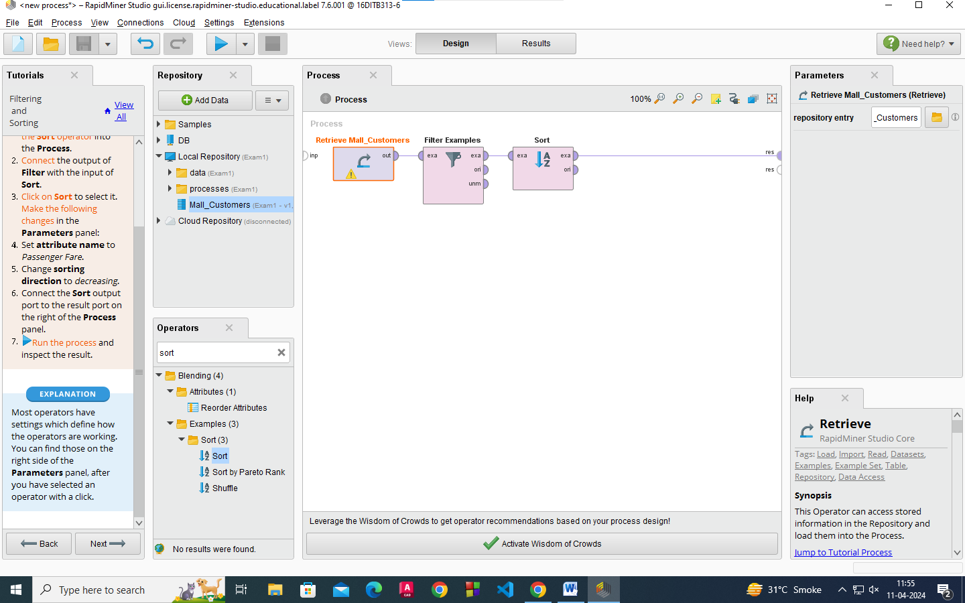

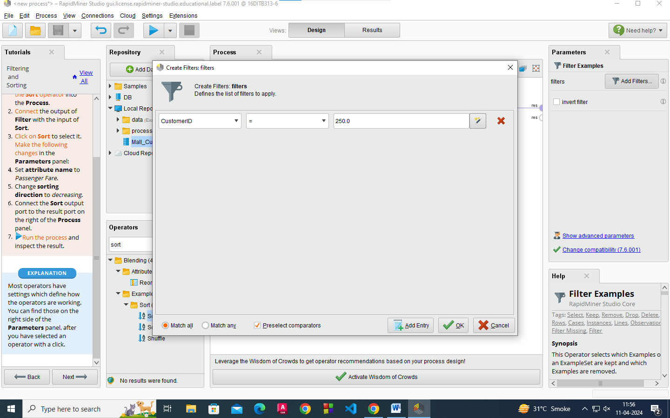
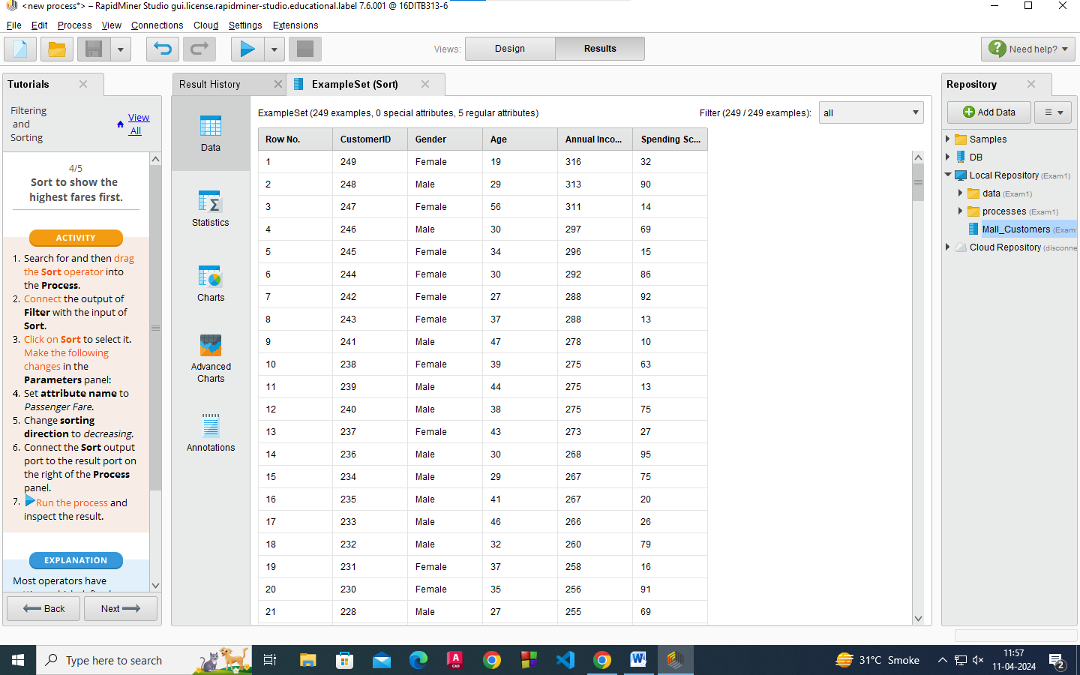

Merging and Grouping

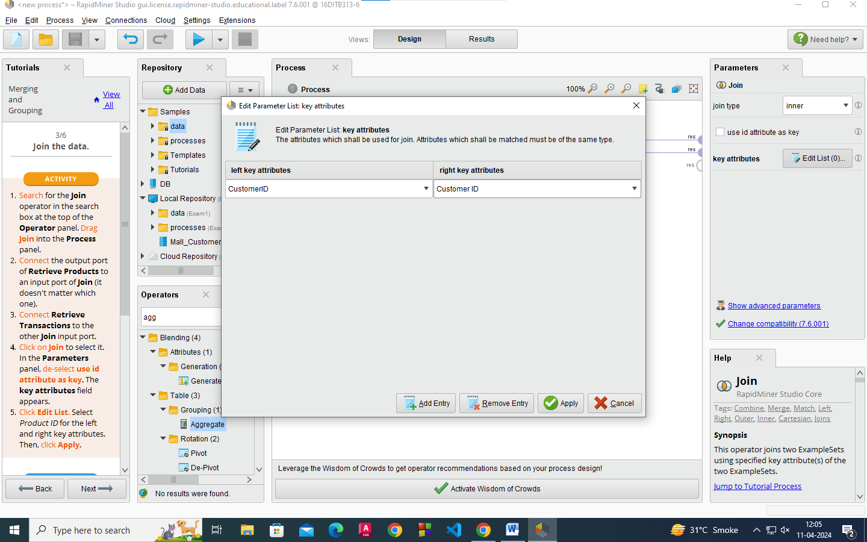
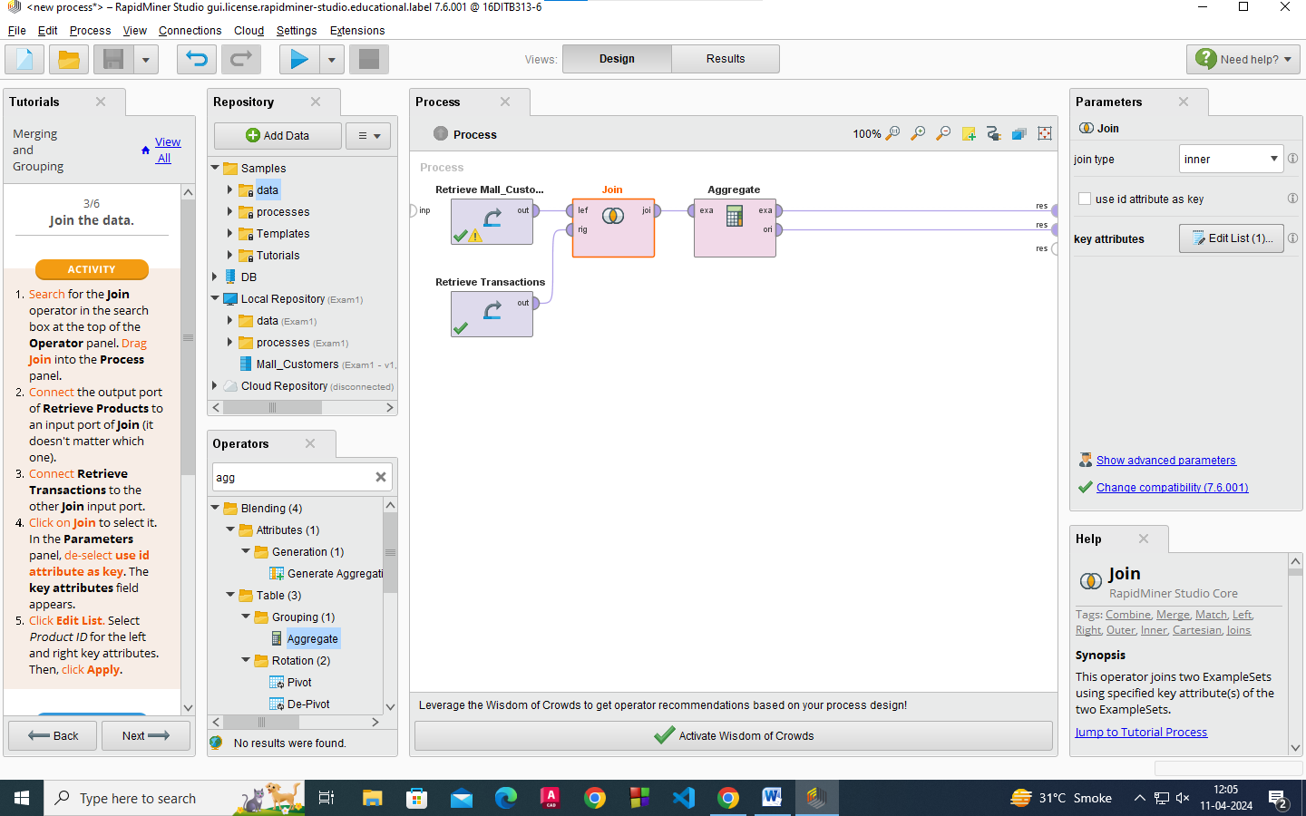

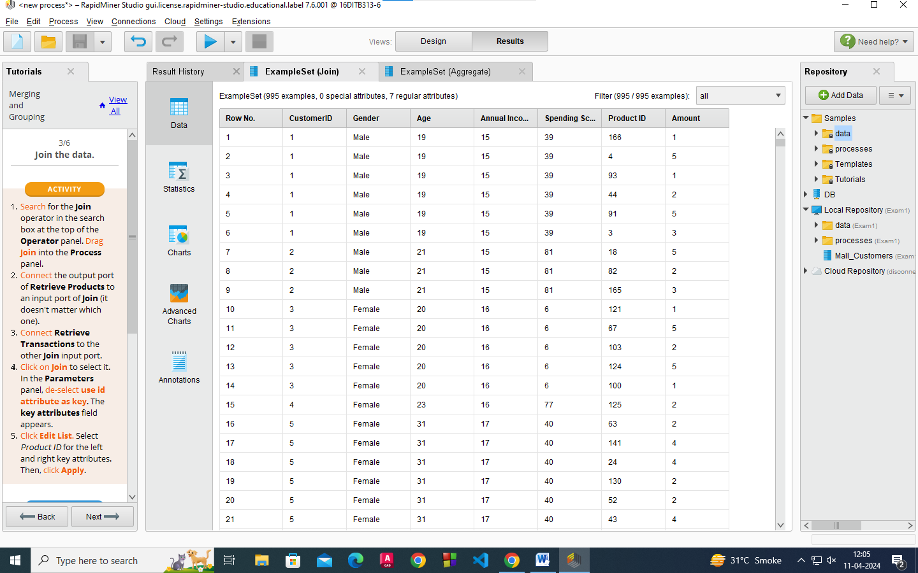
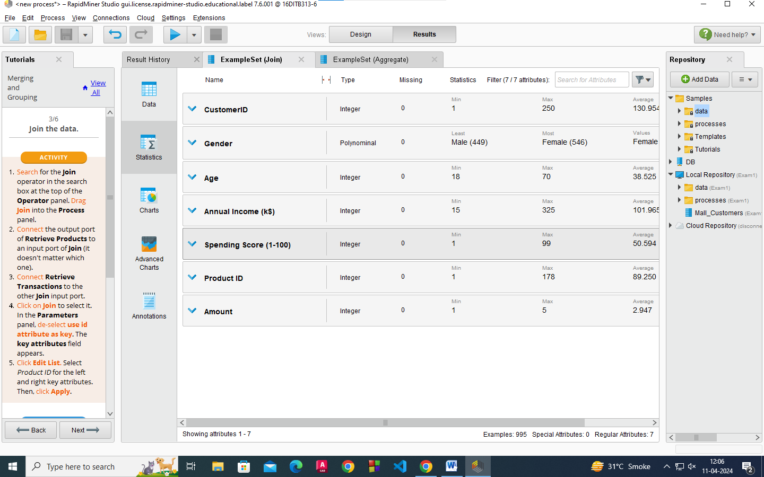

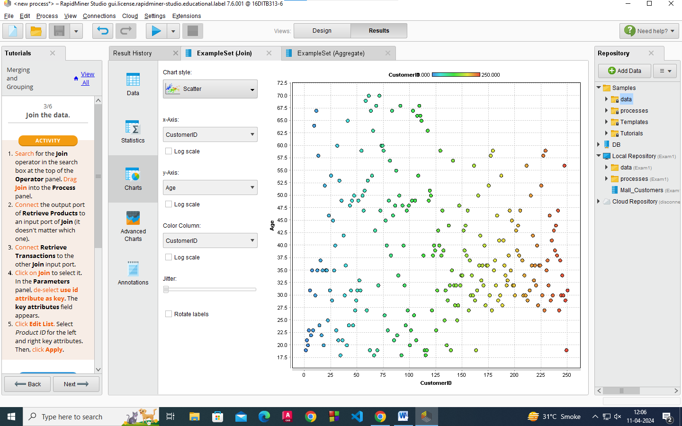
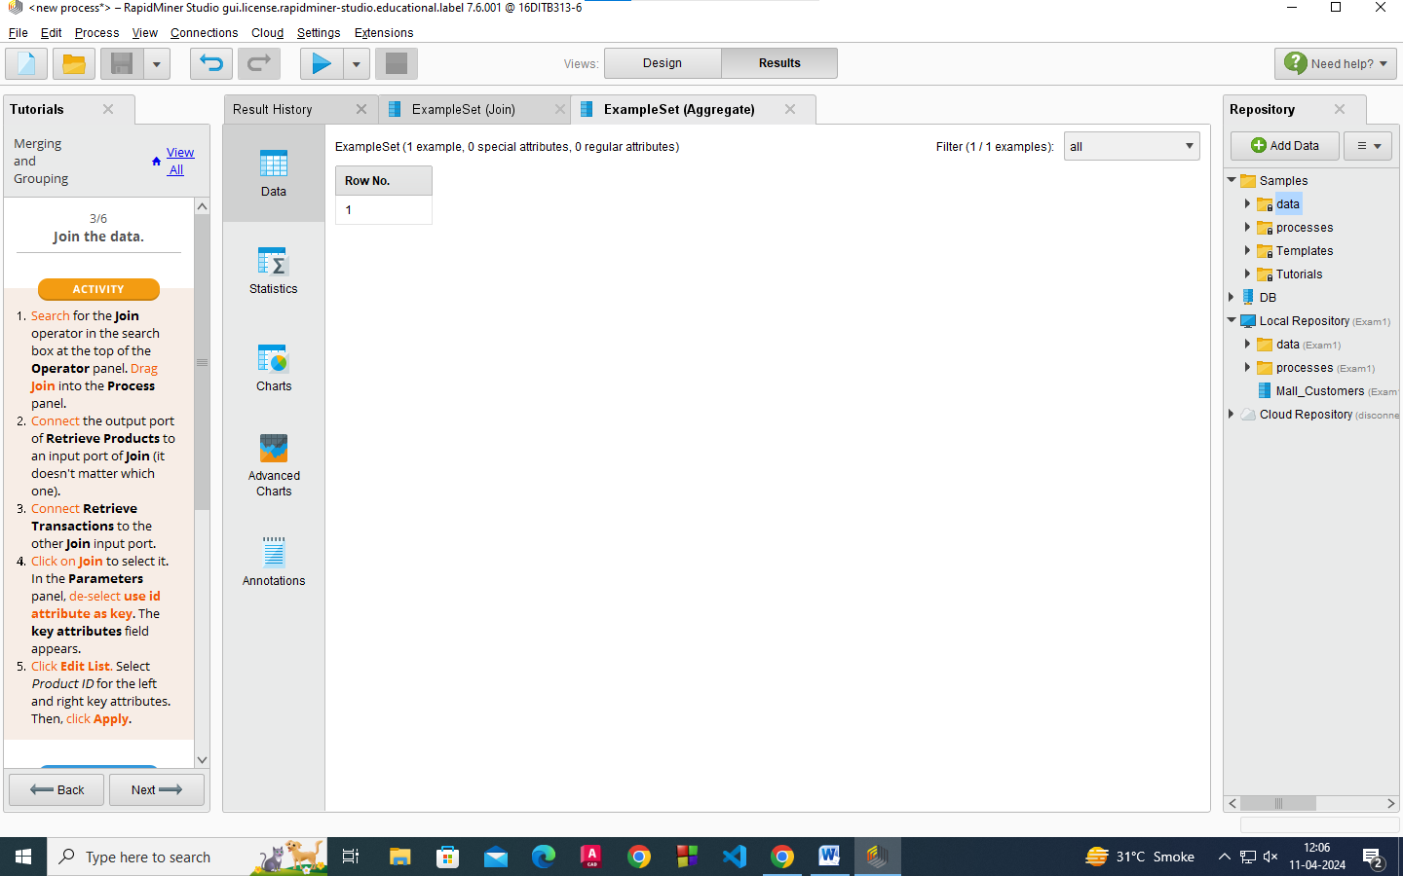

Creating and Removing Columns

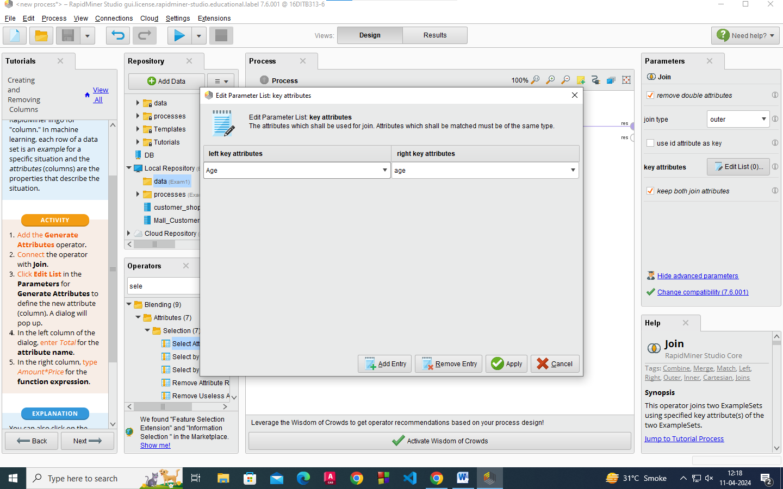
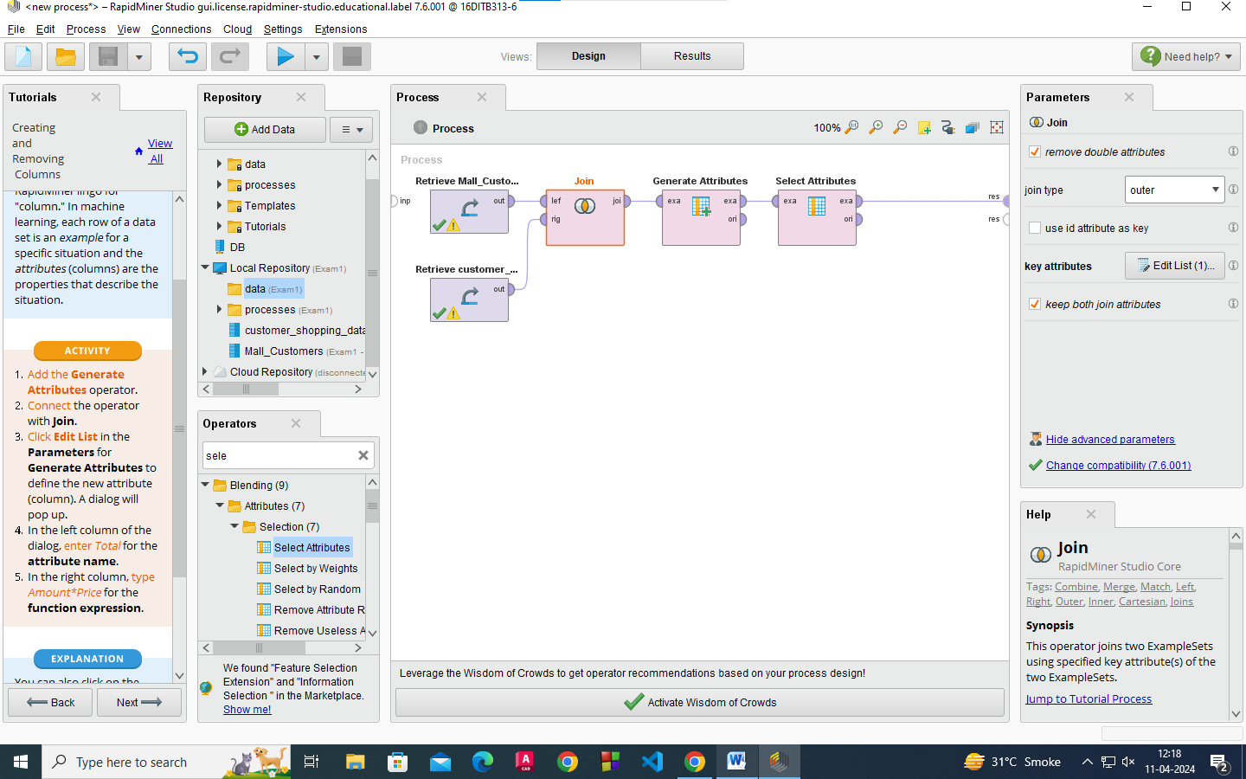

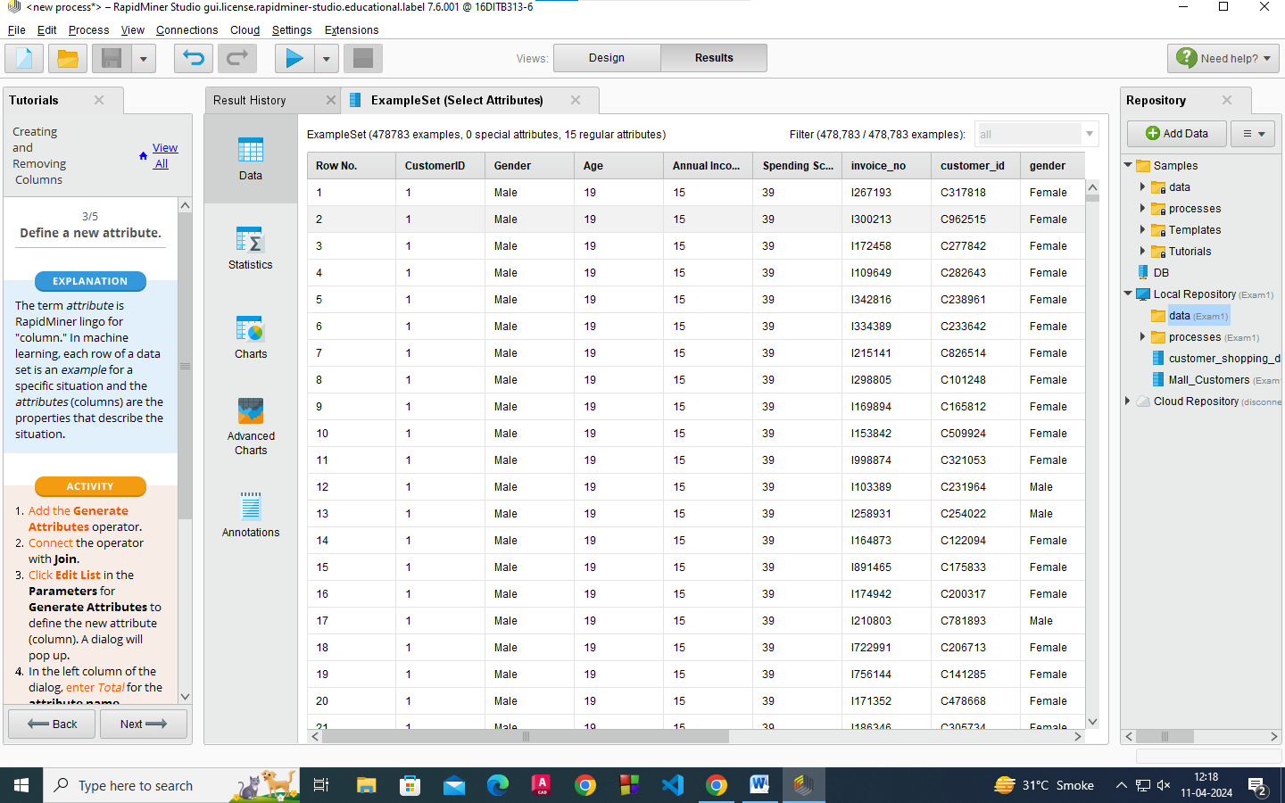
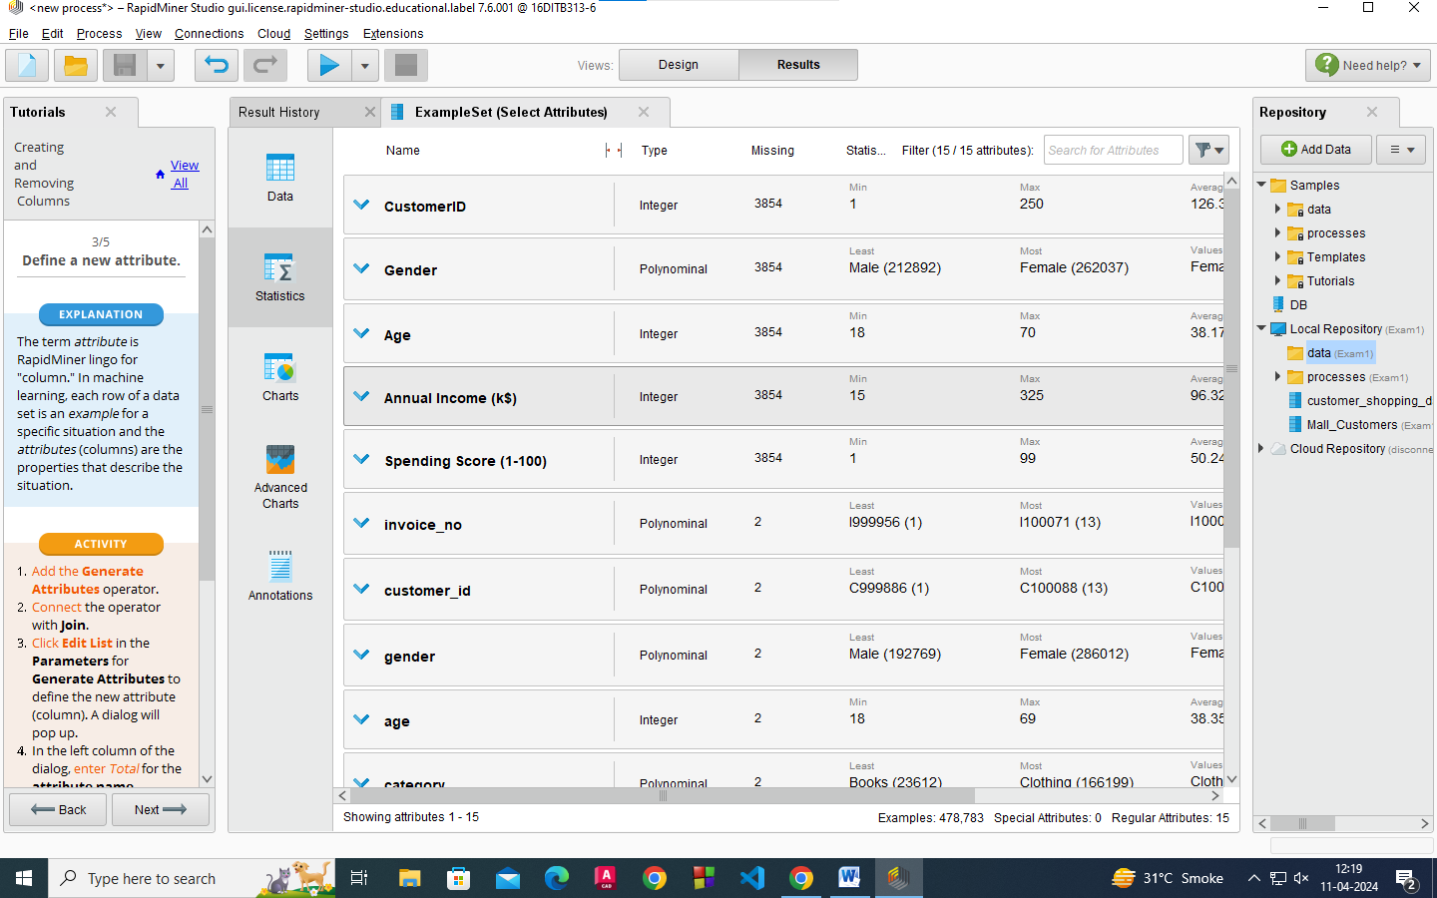

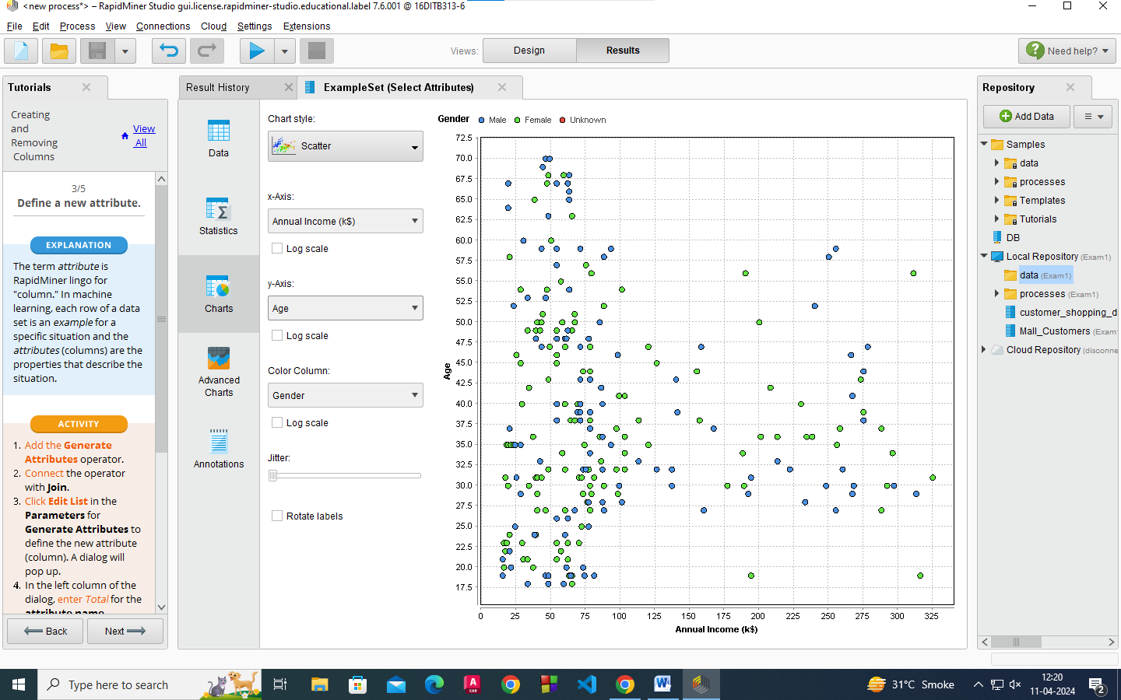

Changing Type and Roles

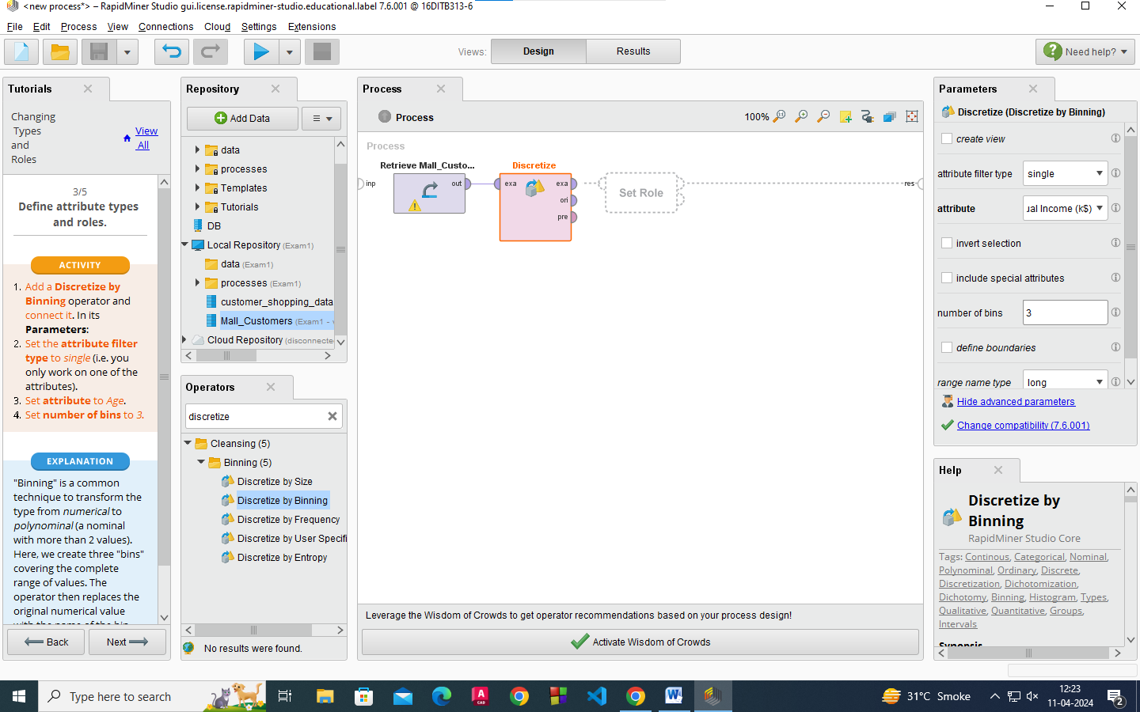

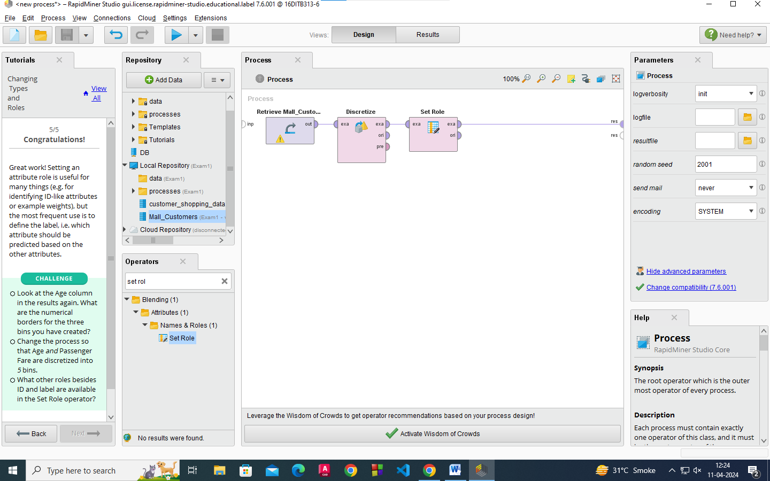
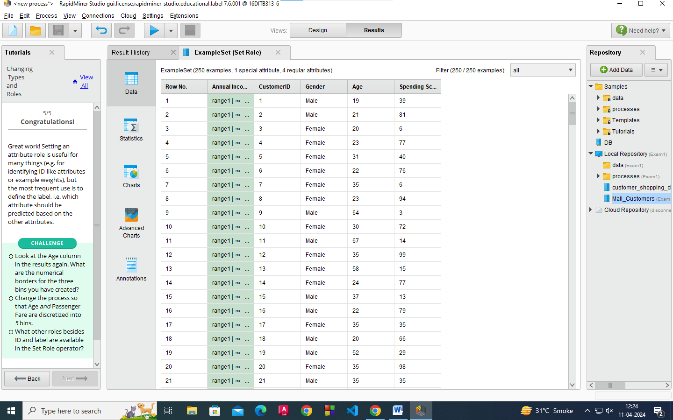

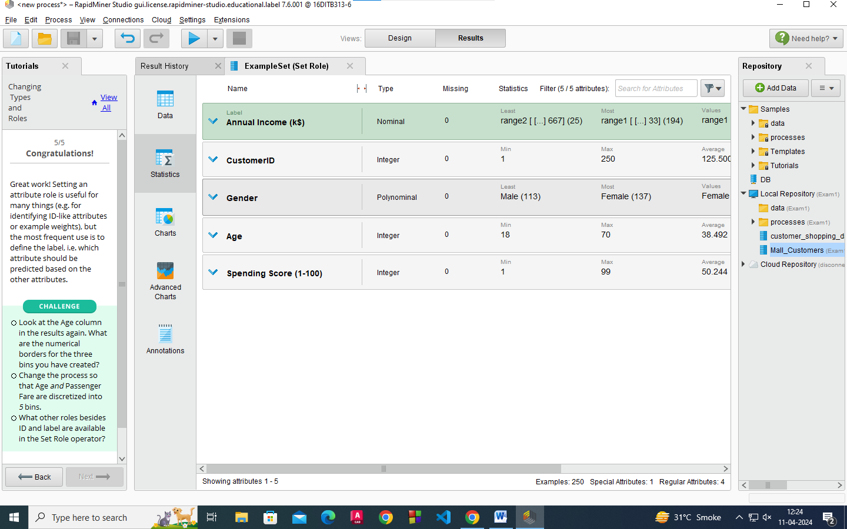
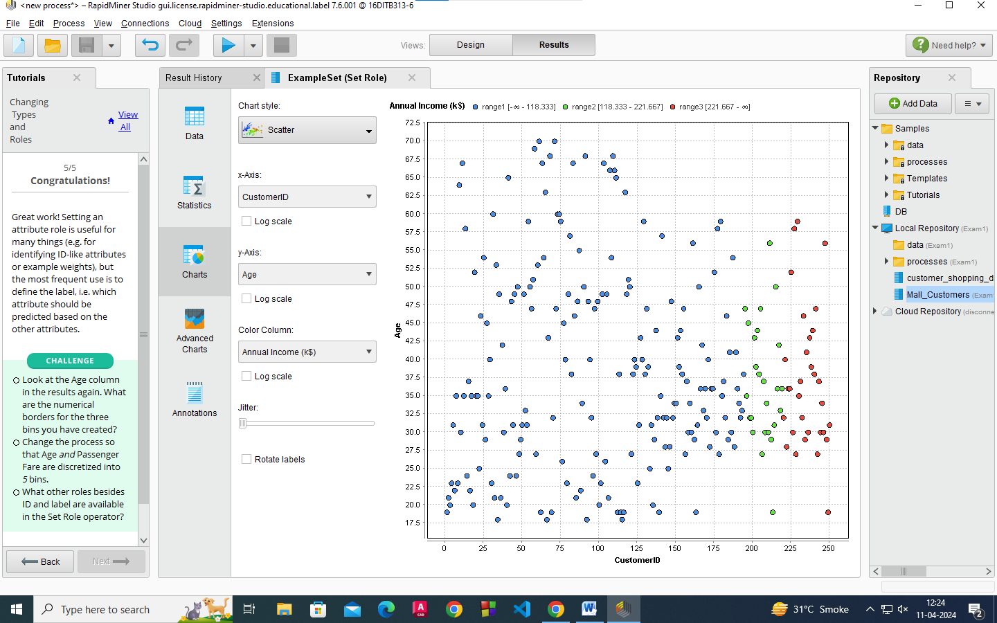

________________________________________________________________________
Results:

Report for ETL
I have taken the dataset of mall customers and customer shopping data from https://www.kaggle.com/datasets/aajay20/mall-customers-datacsv and https://www.kaggle.com/datasets/mehmettahiraslan/customer-shopping-dataset?rvi=1

First Step: Accessing Data
In this step I have imported the data from my computer and stored it in local repository in csv form only. And using Rapid Miner I could access my data in different forms like data(table), statistics and chart form.

Second Step: Filtering and Sorting
In this step I have filtered my mall customer data by CustomerID= not more than 250 by using filter examples operator. And sorted my filtered data in decreasing order using Sort operator.

Third Step: Merging and Grouping
In this step I have used both my dataset and merged it using Join operator by selecting my join type as inner join where my left key attribute is CustomerID and right key attribute is also Customer ID. And grouped it using Aggregate operator.

Fourth Step: Creating and Removing Columns
In this step also I have used my both the dataset and merged it using Join operator by selecting my join type as outer join where my key attribute for left side is Age and on right side is also age. Then by using Generate Attribute operator I have created a new column and by using Select Attribute operator I have selected all columns.

Fifth Step: Changing Type and Roles
In this step I have used Mall customer dataset and by using Discretize operator by binning where I have kept my attribute type Single and attribute as Annual income and no.of. bins as 3. I have also used Set Role operator.

___________________________________________________________________________

Outcomes:
Apply ETL processing and Online Analytical Processing on the warehouse data.
________________________________________________________________________

Conclusion: (Conclusion to be based on the outcomes achieved)
We understood about ETL and OLAP works.
___________________________________________________________________________

Grade: AA / AB / BB / BC / CC / CD /DD

Signature of faculty in-charge with date
___________________________________________________________________________
References:

- https://www.oracle.com/in/database/what-is-a-data-warehouse
- Paulraj Ponniah, “Data Warehousing: Fundamentals for IT Professionals”, Wiley India

